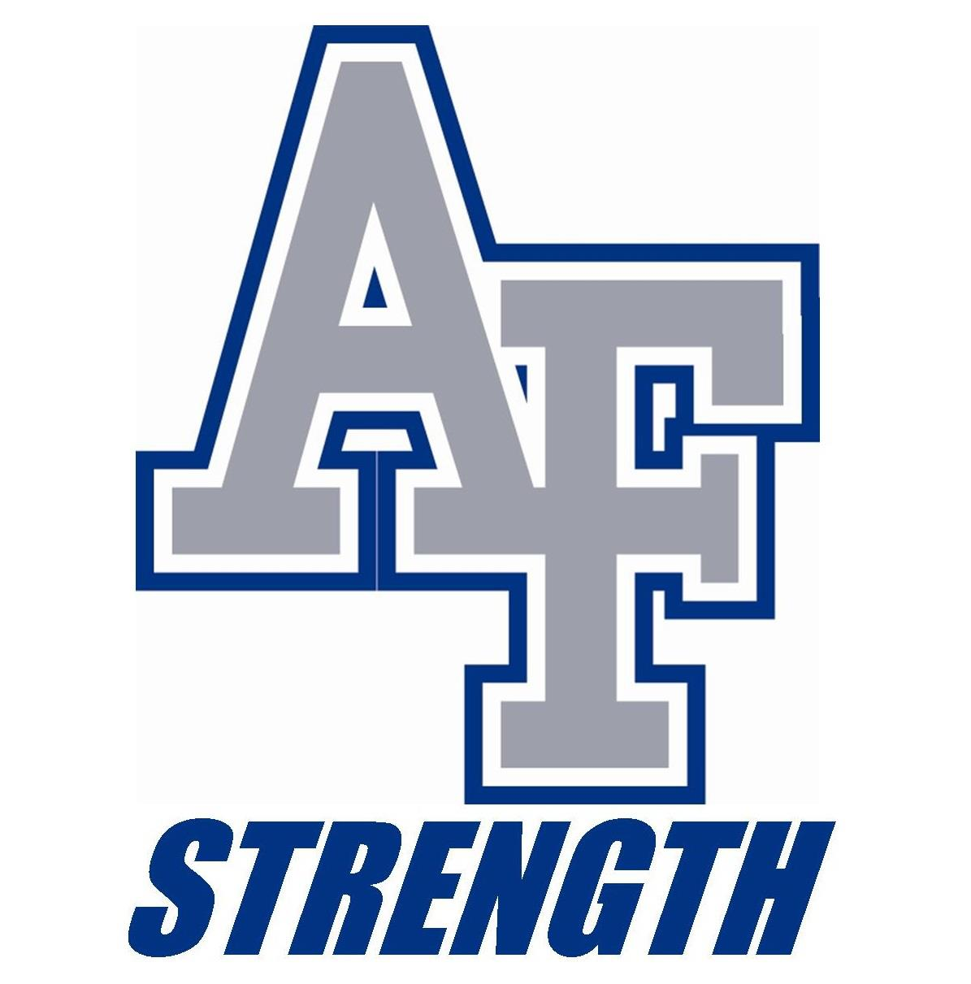

Strength and Conditioning
Internship Program
Now accepting applications for the 2021 Fall Semester
Deadline May 31, 2021

PERSONAL INFORMATION:
First Name _____________________________
Last Name _____________________________
Phone Number
(____)________________________________
Email
_____________________________________
EDUCATION:
Name of School/University
_________________________________________________________________
Major
_________________________________________________________________
Expected Graduation Date
_________________________________________________________________

Signature______________________________ Date__________________________________
Please fill out form and email to bradley.raines@afacademy.af.edu with the subject line reading:
Last Name. First Name.Fall21 (i.e. Raines.Brad.Fall21)
Please submit your resume, cover letter and 3 letters of recommendation with your application form.

